AWS XRAY   
1. What is XRay : XRAY is a service that collects data about requests that your application servers. It also provides tools that you can use to view, filter, and gain insights into that data to identify issues and opportunities for optimization.

2. You can visualize your serverless applications, and find out what’s wrong if it not working.  
  
With X-Ray you can

|  |  |  |
| --- | --- | --- |
| create a service map | Identify errors and bugs | Build your own analysis and visualization apps |

3. For any traced request to your application, you can see detailed information not only about request and response, BUT also about calls that your application makes to downstream - > aws resourses, microservices, databases, HTTP web api’s.  
  
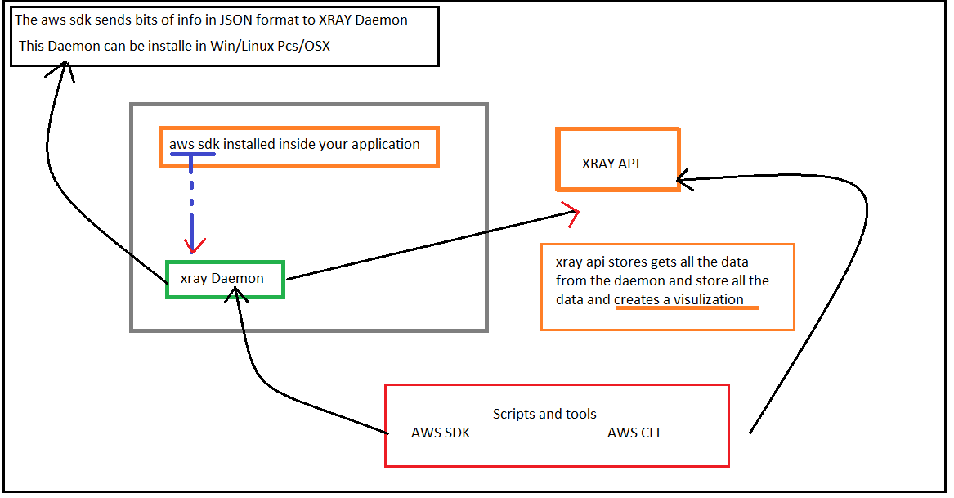

4. The SDK provides.

The interceptors : To add to your code to trace incoming http requests.

The client handlers : To instrument AWS SDK clients that your application uses to call other services.

A HTTP client : To use to instrument calls to other internal and external HTTP web services.

5. XRAY Integration.

XRAY integrates with

|  |  |  |
| --- | --- | --- |
| Elastic Load Balancing | AWS Lambda | Amazon API Gateway |
| Amazon EC2 | AWS Elastic BeanStalk |  |

6. Languages supported by XRAY

|  |  |  |  |  |  |
| --- | --- | --- | --- | --- | --- |
| Nodejs | Go | Python | Java | .net | Ruby |

7. LAB : Lets try to instrument aws with xray. Nodejs Lambda - XRAY  
  
X-Ray helps developers analyze and debug production, distributed applications such as those built using a microservices architecture. With X-Ray we can understand how our application and its underlying services are performing.  
This will help us identify and troubleshoot, and find the root cause of , Performance issues and errors.

XRay stores data for the last 30 days, probably in a S3 bucket.  
  
7.1 : Create a cloud9 Environment. While creating, it will ask for a machine so that cloud9 can SSH to or it will create a EC2 instance. Node that you have to npm init and npm install the below dependencies.  
Create a lambda function and deploy it.  
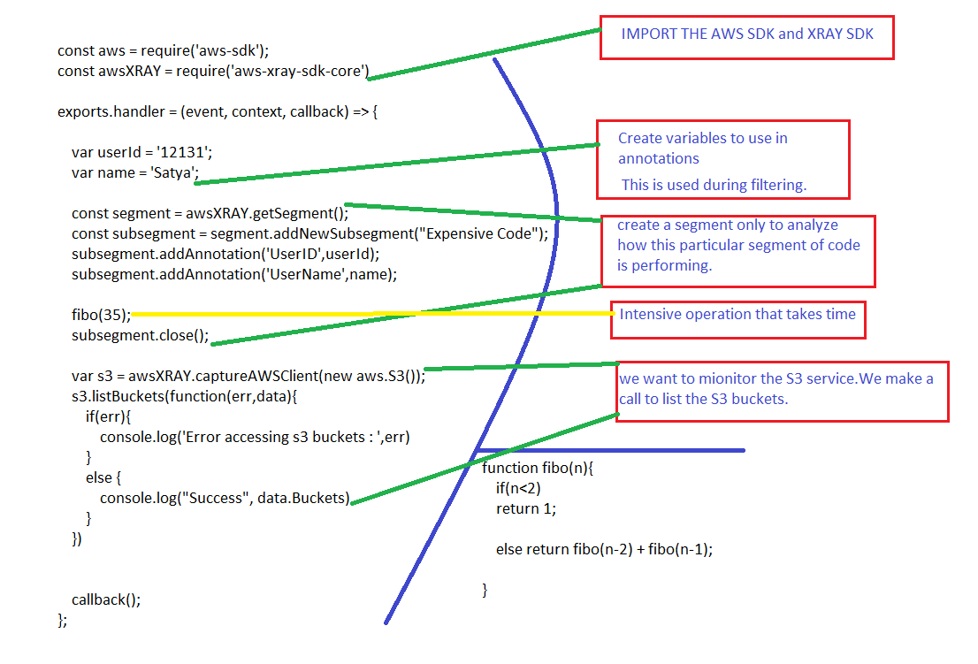

7.2 As soon as you deploy. Go to lambda and attach a ‘S3 full access policy’ to the Role that is automatically created for the existing lambda function (as the lambda wants to access the S3 service to list all the buckets).  
Enable view Tracing in the lambda function.  
Run a few ‘Test’s and go to XRAY and see the logs.  
  
7.3 The service Map that is generated is as below.  
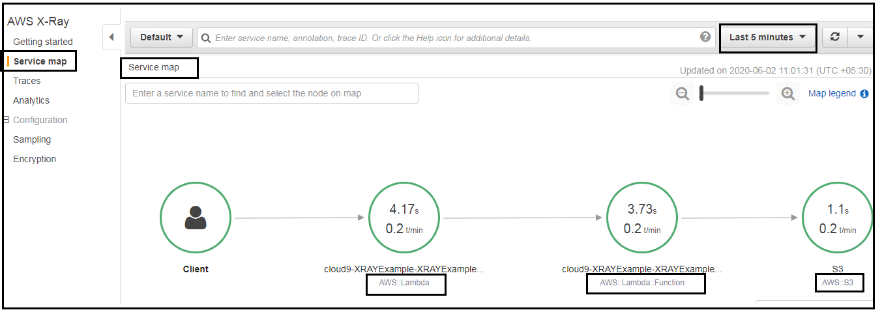  
  
7.4 Click on any one to see Service Details.  
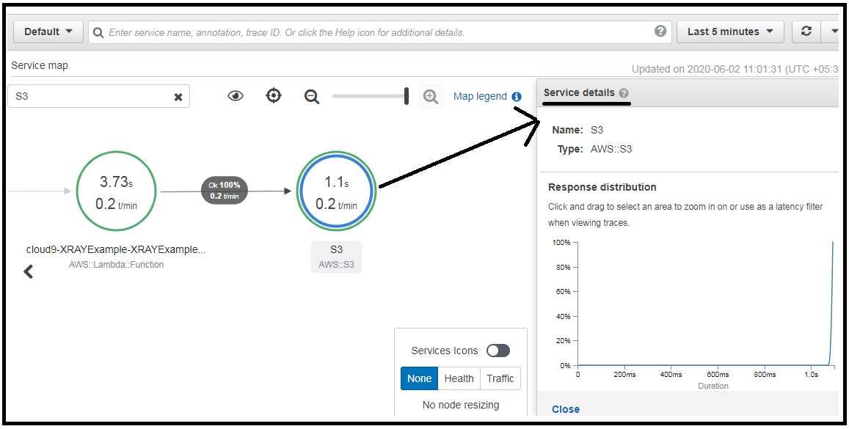  
  
7.5 Click on the ‘Traces’ button of Each Service [beside the close button]  
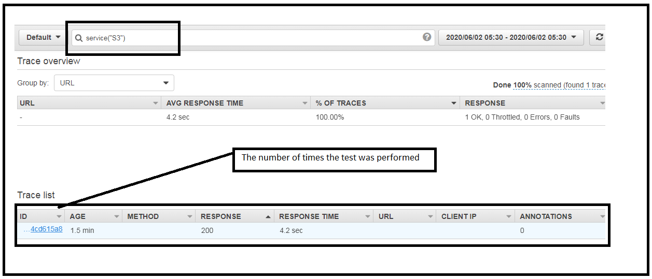  
As we have clicked once we this only one trace  
  
7.6 Clicking on each traceID will show the line information.  
Notice the Expensive code row : We can debug performance issues via this time spent here.  
S3 calls : Any calls made to S3 are listed here and the time spent over that api call .  
  
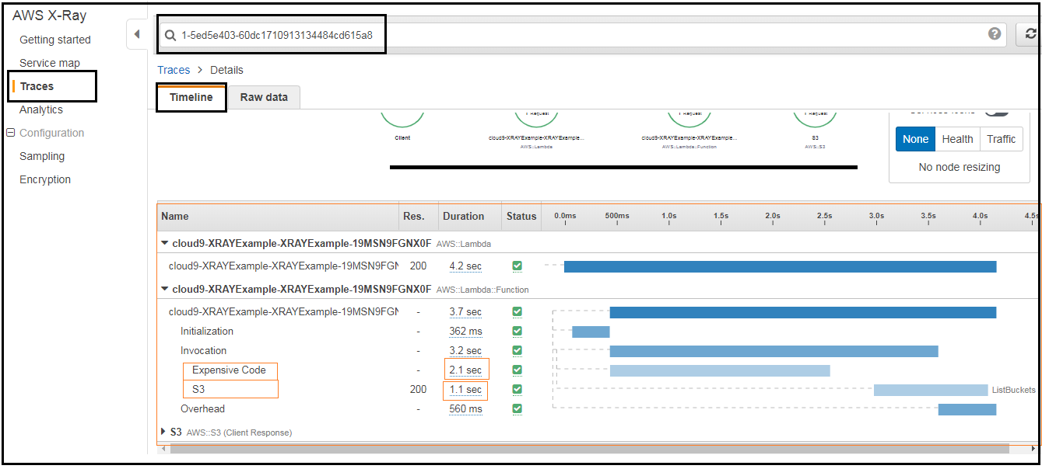

7.7 : We can click on the Expensive code row.  
And we can see the annotations. This will help you find for what userID / requests we had this performance problem. Notice the code in the nodejs code where we add the annotations to the XRAY SDK.  
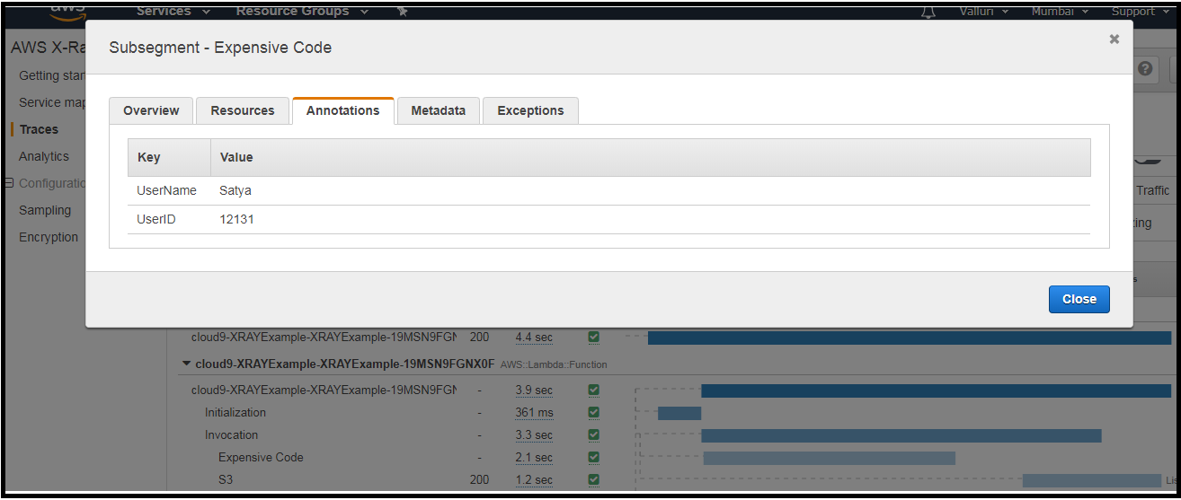

7.8 Filtering : It can be performed in two ways which are shown below by creating a group and also by typing the annotations

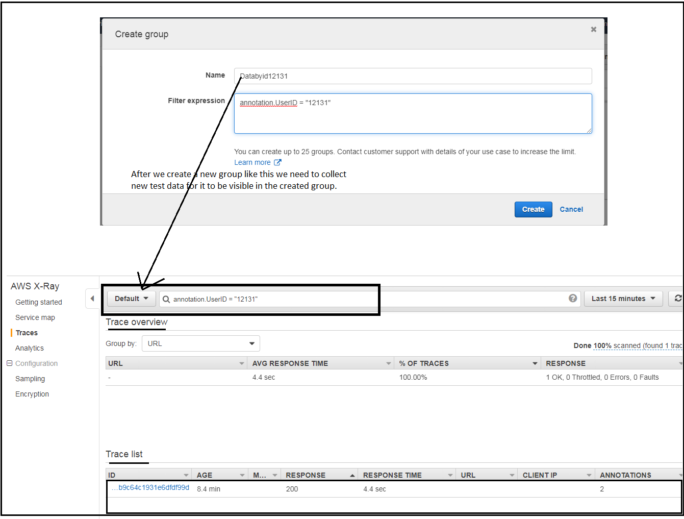

Service map by above filter.  
